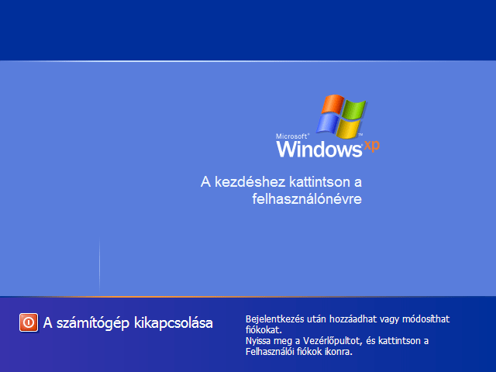
http://www.google.hu/imgres?q=windows+k%C3%A9perny%C5%91&um=1&hl=hu&sa=N&biw=1024&bih=574&tbm=isch&tbnid=d1bdcAUObh_ANM:&imgrefurl=http://www.nagykutya.hu/index.php%3Fmodule%3Dblog%26first%3D186&docid=QKORJeGbrrufpM&imgurl=http://www.nagykutya.hu/pictures/windows_login_original.png&w=640&h=480&ei=WdVMT_2HJcfHswaluOiPDw&zoom=1&iact=hc&vpx=278&vpy=141&dur=71&hovh=194&hovw=259&tx=139&ty=69&sig=117512574992696100316&page=1&tbnh=117&tbnw=156&start=0&ndsp=15&ved=1t:429,r:1,s:0
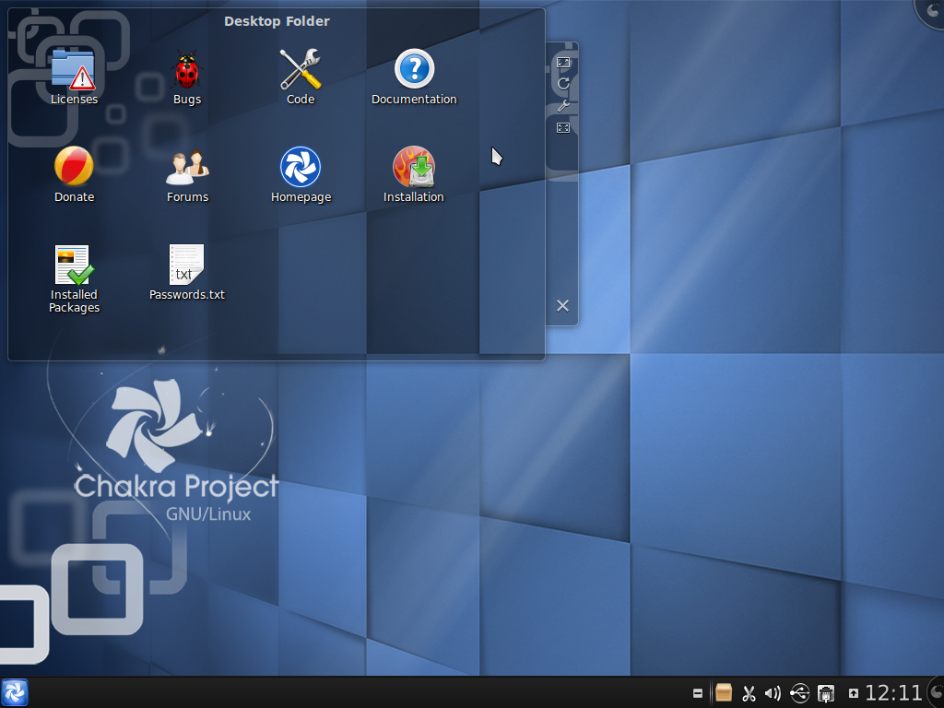
http://www.google.hu/imgres?q=linux+k%C3%A9perny%C5%91&um=1&hl=hu&biw=1024&bih=574&tbm=isch&tbnid=bhAnLcRl3MxQlM:&imgrefurl=http://linuxhogyanok.blogspot.com/2011/07/chakra-201109-megszeliditett-oroszlan.html&docid=YxVKZo4fJ_-BkM&imgurl=http://4.bp.blogspot.com/-R_YPZNDppOE/Thivz_W-y3I/AAAAAAAAIf4/ZP_JpI6uAIM/s1600/Linux%25252B%2525255BFut%2525255D%25252B-%25252BOracle%25252BVM%25252BVirtualBox_003.png&w=1024&h=768&ei=jNVMT83kMcnXtAaVhuCMDw&zoom=1&iact=hc&vpx=601&vpy=169&dur=2&hovh=194&hovw=259&tx=169&ty=124&sig=117512574992696100316&page=1&tbnh=114&tbnw=157&start=0&ndsp=15&ved=1t:429,r:13,s:0
http://www.google.hu/imgres?q=macos+k%C3%A9perny%C5%91&um=1&hl=hu&biw=1024&bih=574&tbm=isch&tbnid=6xIW6AApgz9_7M:&imgrefurl=http://torrentkereso.hu/torrent/mac-os-lion-10-7-v2-torrent-1420977.html&docid=7qZipFym7p0_OM&imgurl=http://img196.imageshack.us/img196/4411/lionserver.png&w=1189&h=793&ei=u9VMT52dLofltQaa0-mLDw&zoom=1&iact=rc&dur=328&sig=117512574992696100316&page=5&tbnh=123&tbnw=164&start=77&ndsp=20&ved=1t:429,r:0,s:77&tx=40&ty=61

